

E-Learning Portal

Group 5

Names : 1. Christian Frans Mukuan / 1920010040

2. Deyaninta Ekabriela Permata / 1920010050

Class : 4SC3

CEP CCIT

FAKULTAS TEKNIK UNIVERSITAS INDONESIA

2021

**Developed by**

1. **Christian Frans Mukuan / 1920010040**
2. **Deyaninta Ekabriela Permata / 1920010050**



**PROJECT ON**

*E-Learning Portal*

**E-Learning Portal**

Batch Code : 4SC3

Start Date : March 19th, 2021   
End Date : April 06th, 2021

Name of Faculty : Mr. Tirta Akdi Toma Mesoya Hulu, S. Kom

Names of Developer :

1. Christian Frans Mukuan / 1920010040
2. Deyaninta Ekabriela Permata / 1920010050

Date of Submission: April 07th, 2021

**CERTIFICATE**

This is to certify that this report titled “E-Learning Portal” embodies the original work done by Christian Frans Mukuan, and Deyaninta Ekabriela Permata. Project in partial fulfillment of their course requirement at NIIT.

Coordinator:

Mr. Tirta Akdi Toma Mesoya Hulu, S. Kom



**ACKNOWLEDGEMENT**

First of all, thanks to Allah SWT because we can complete this Project task both in the form of a presentation. We want to deliver sincere especially for Mr. Tirta Akdi Toma Mesoya Hulu as faculty and another faculty who always help. Thank you also to fellow students who have supported, and also thank you for being fellow workers in the education at CCIT-FTUI.

The Project paper entitled ‘E-Learning Portal' the writers submits as Project's 2021 task requirements.

The hope of the writers hopefully this paper can be useful for all so that it can add knowledge and insight. The writers realize that this paper is far from perfect. Therefore, the writers expect all suggestions and criticisms from readers who are constructive for the perfection of this paper.

Jakarta, April 7th 2021

Writers

**SYSTEM ANALYSIS**

1. **System Summary**:

E-learning, as a new version of distance learning, is applied via the Internet technologies and involves the educational activities, which do not require the presence of the teacher and learner at the same time and place. E-Learning Portal exists as educational solutions, to make it easier for students to submit their assignments and also they can call or chat their teacher.

1. **Technology:**

Our project is about the design and prototype of a mobile application using an application design in the form of Adobe XD. In this project, we created an application that provides a schedule of assignments, call and chat features, and many more. The tool we used is **Adobe XD**. After the design is complete, we implement our design results into code using **Flutter** software.

1. **Wire Framing Process :**

* Identify the Constraints
* In the wireframing process we used an iPhone X with a size of 375 x 812.
* Represent Wireframe low fidelity

Contains of log in page, home page, assignment page, and chat page

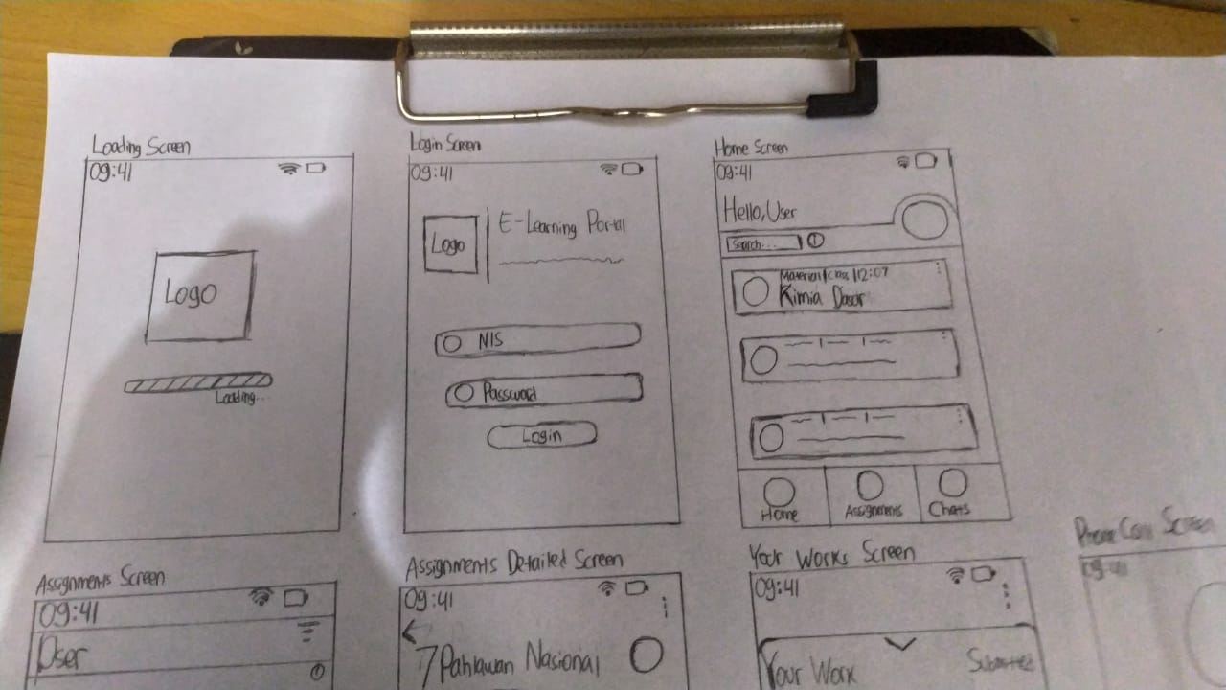

**SYSTEM ANALYSIS**

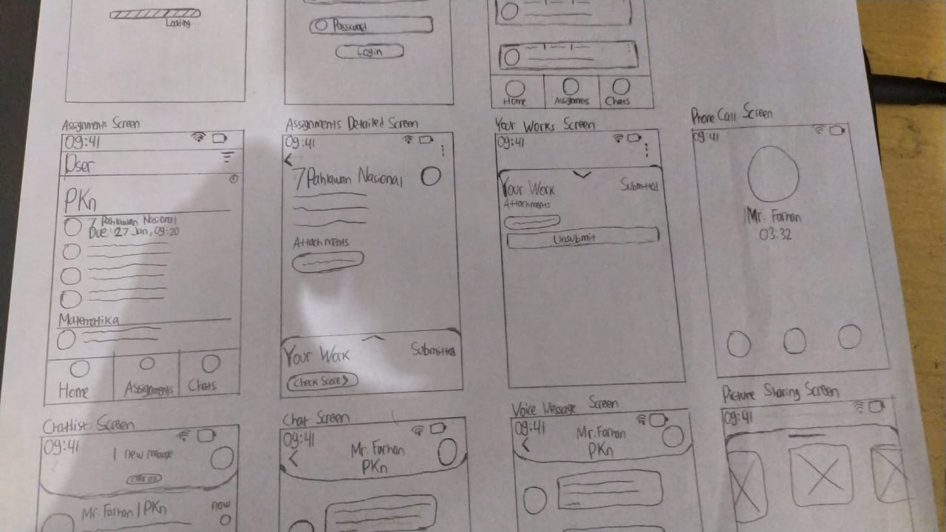

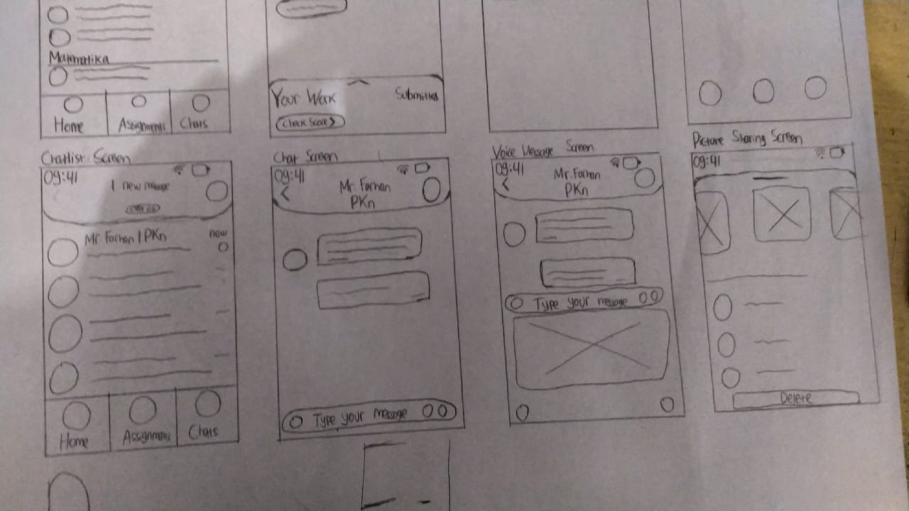

**DESIGN INTERFACE**

* High Fidelity Splash Screen log in and log out

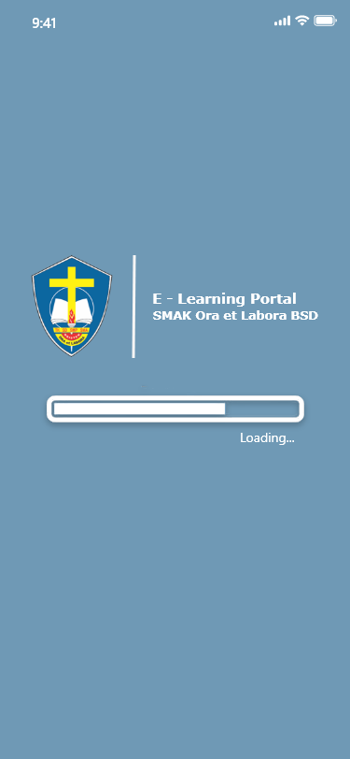 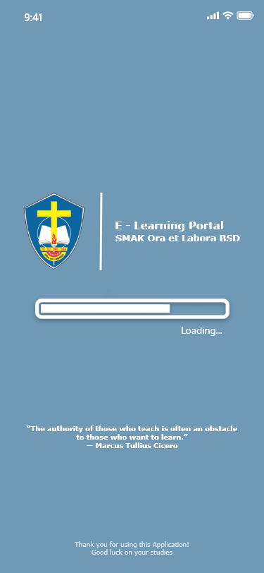

* High Fidelity Login and Sign Up  
    
  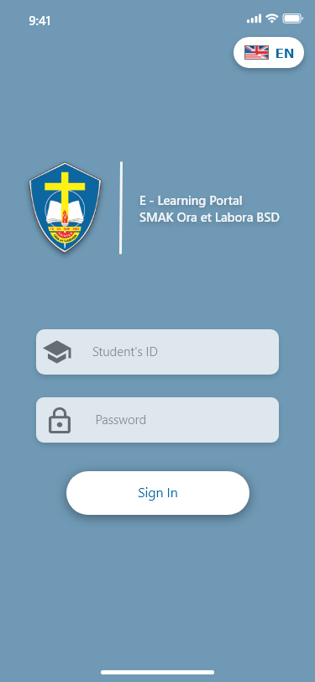 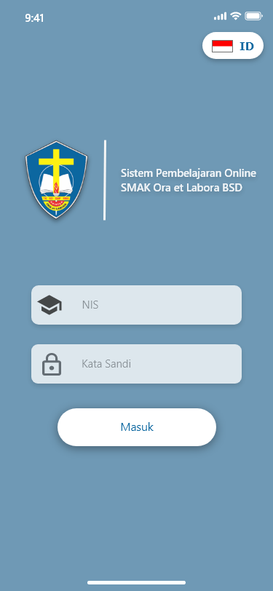

\

sssssssssss

**DESIGN INTERFACE**

* High Fidelity Home Page and Preview Assignments

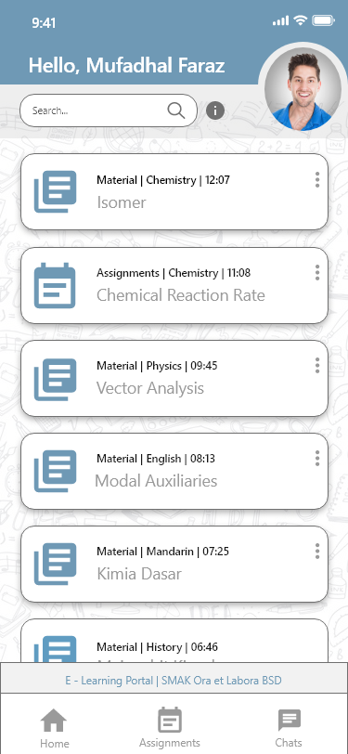 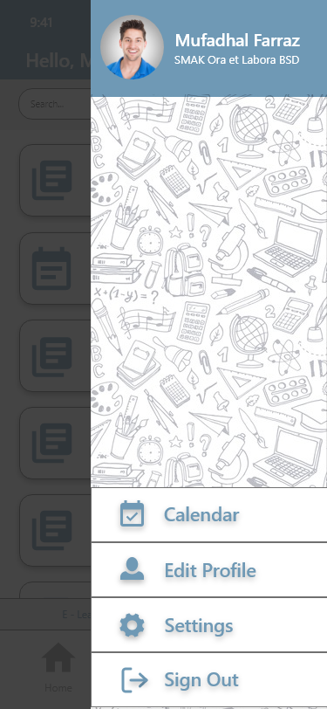 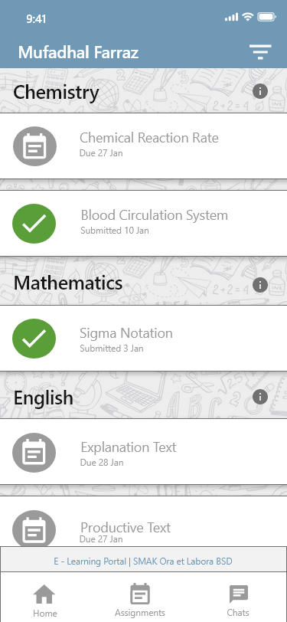  
  
 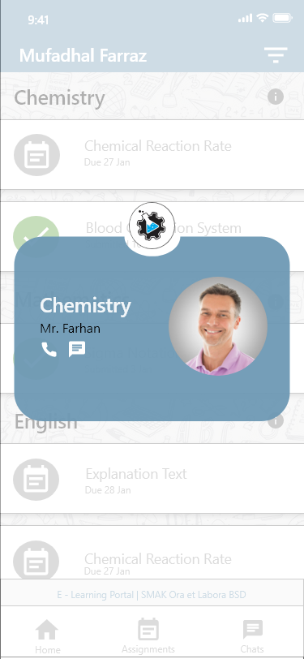 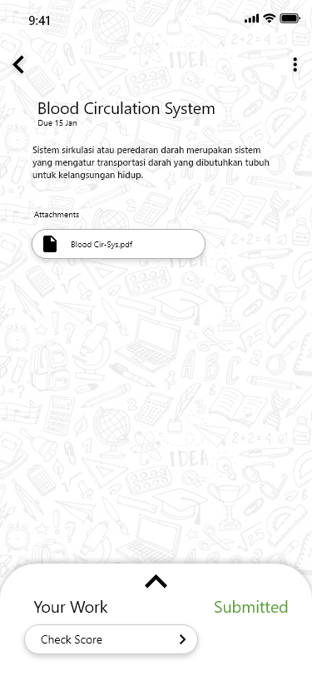 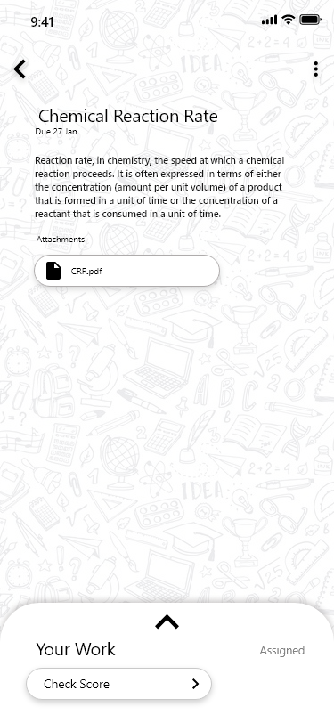

\

sssssssssss

**DESIGN INTERFACE**

* High Fidelity Preview Material

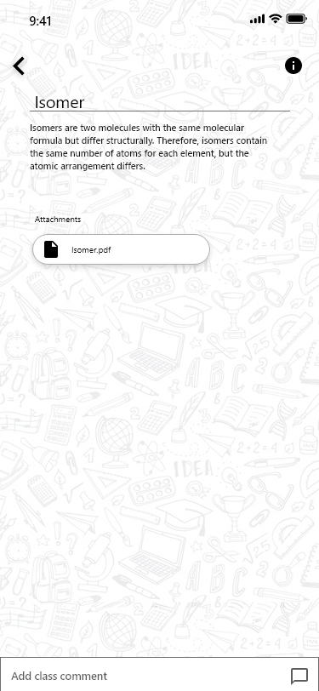 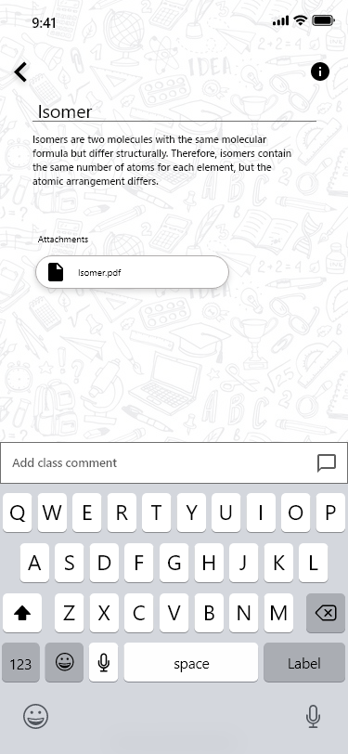 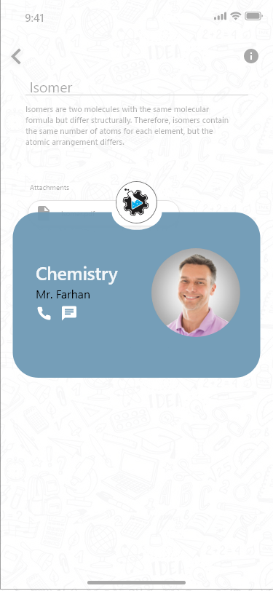

* High Fidelity Assignments details  
    
  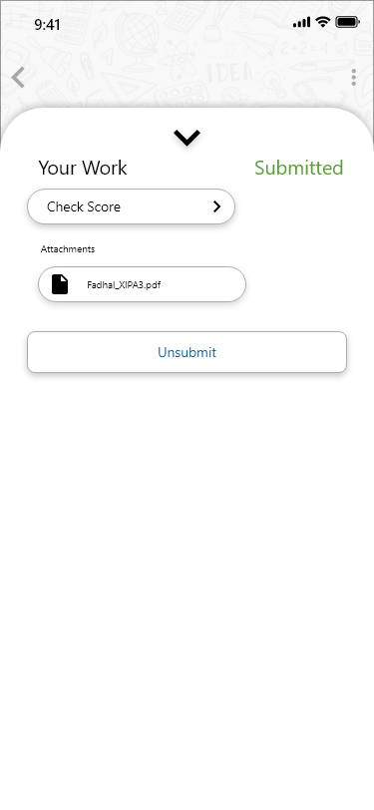

\

sssssssssss

**DESIGN INTERFACE**

* High Fidelity Sorting Method

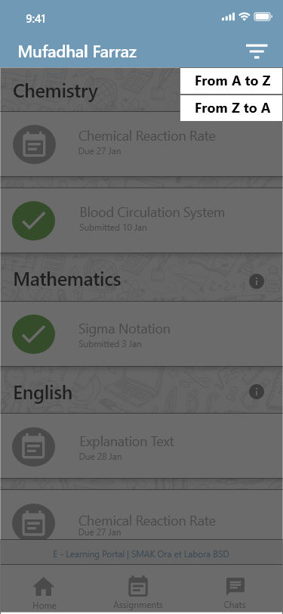 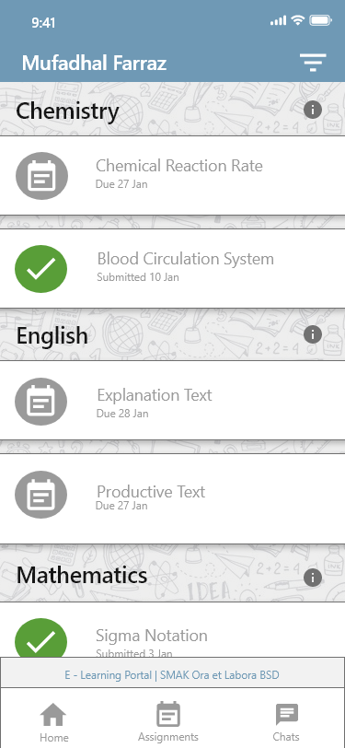 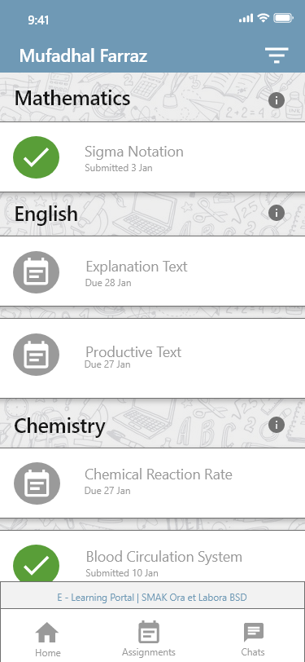

* High Fidelity Chat Features  
  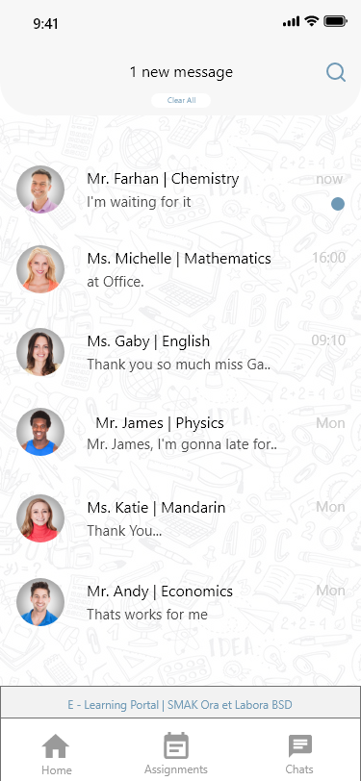 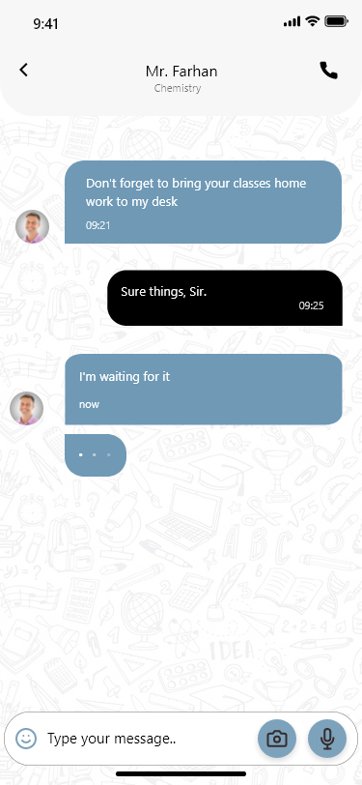 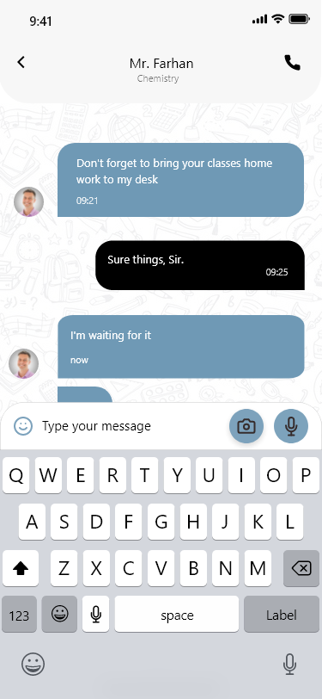

\

sssssssssss

**DESIGN INTERFACE**

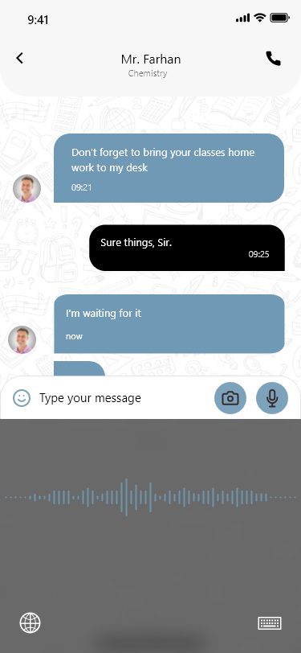 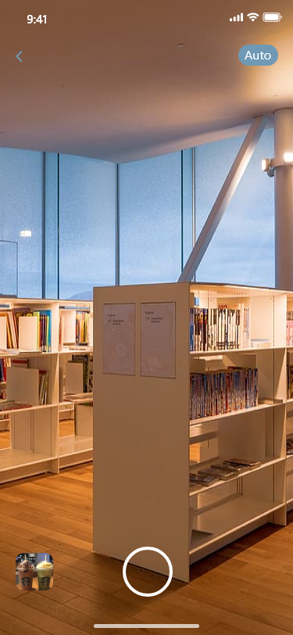 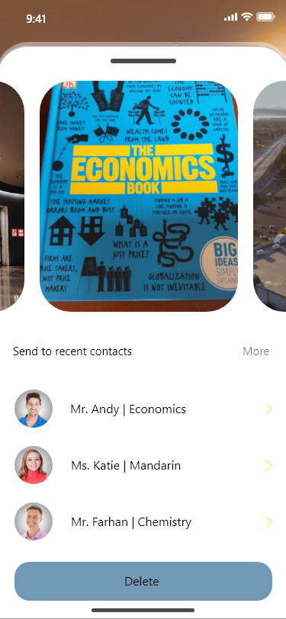 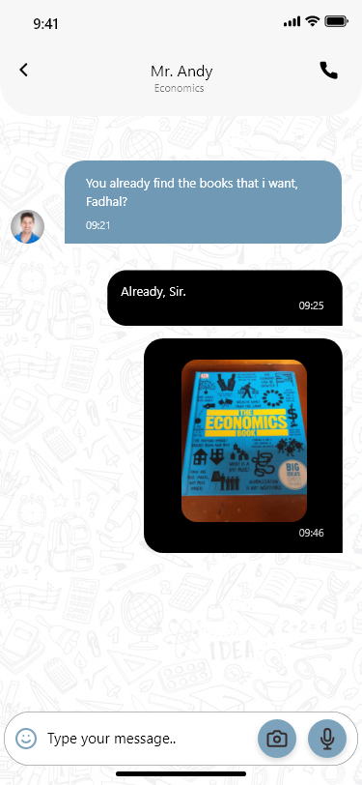

* High Fidelity Calls Features  
    
    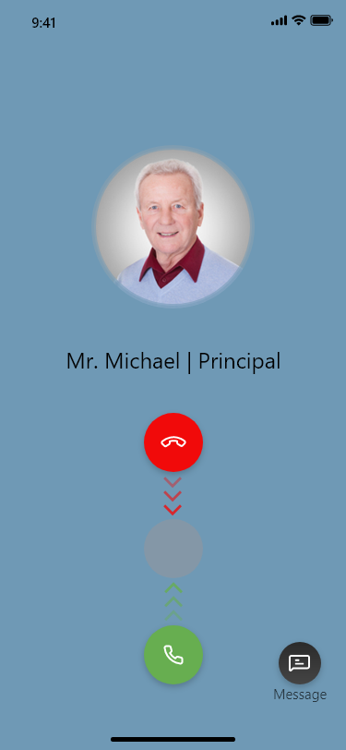

\

sssssssssss

**PROJECT FILE DETAILS**

|  |  |  |
| --- | --- | --- |
| **S.No** | **File Name** | **Remarks** |
| 1. | E-LearningPortal.xd | Adobe XD |
| 2. | E-Learning.pptx | To Presentate our projects |

\

sssssssssss